http://phpqrcode.sourceforge.net/qrsample.php?data=QR+Based+24X7+Smart+ATM+System&ecc=L&matrix=1

IJESC logoISSN 2321 3361 © 2021 IJESC

**Research Article Volume 11 Issue No.04**

QR Based 24X7 Smart ATM System

P. Vijayalakshmi1, P.Monisha2, G. Nagiya Bhanu3, B. Niranjana4 Associative Professor1, UG Scholar2, 3, 4

Panimalar Engineering College, Chennai, Tamilnadu, India

# Abstract:

The ATM System is used to access their bank accounts in order to make cash withdrawals. Whenever the user needs to make cash withdraws, they can enter their PIN number and the amount to be withdrawn in the form of 100’s 500’s and 2000’s. Once their withdrawn was successful, the amount will be debited in their account. It requires more and more time .So, in order to reduce that inconvenience, we introduce this proposed concept for the ATM simply by showing Quick Response Code and Biometric to withdraw their money within 30 sec.

**Keywords:** Android Studio, Python, QR Code Reader ATM, Smart Phone.

# INTRODUCTION

A big fear during COVID-19 has been associated with the use of ATMs. To ensure that the entire process of withdrawing money from ATMs is done without touching the machine or the screen is looking possible now. And now the ATM users can withdraw cash from an ATM by just scanning a QR code on the mobile phone by ATM machine’s screen without touching the surface. And along with that ATM Card has complications in validating and performing transmission process. Therefore, the secret code was stolen while entering PIN at the ATM machine by peeping attack. So the data of a user is to be ensured that secure and it is safe from the data leakage and other attacks.

# RELATED WORK

B. Saranraj, N. Sri Priya Dharshini, R. Suvetha, K. Uma Bharathi has proposed to offer protected and secured support to the ATM users to do exchanges without going to bank. Each record holder have their own exceptional ATM card, each having a unique account number. To abstain from compromising in ATM machines, their proposed system gives safe arrangements, for example, biometric authentication. ATM cards will be having the data about unique mark. The primary target of this work is to guarantee a better security in ATM exchanges. RFID tag can also be used rather than ATM card.

Gokul.S, Kukan.S, Meenakshi.K, Vishnu Priyan S S, Rolant Gini J, M.E.Harikumar has proposed that in the present world, the usage of ATM to withdraw cash has been increased. At the same time, theft and robbery cases have also increased that calls for the need of much-secured ATM that provides additional features for security. Their work aims at security- based smart ATM which functions based on RFID and fingerprint authorization for its access. The RFID number and fingerprint details are obtained from the users after which the recognized card number, authorization status, and location of access are passed on for checking its authenticity with the database details. Once the information are validated with the retrieved database details then the corresponding account holder gets the message whether the authorization is valid or not. Even the location, time, and date of the access are also informed to the account holder. Additionally, this system can

enhances the security by placing vibration and flame sensors which immediately notify in case of fire and breakage.

Arju Aman, Aryan Singh, Ayush Raj Sandeep Raj has proposed that in recent years, consumer electronics for providing better customer service has a significant growth. For production, storage and supply of goods to consumers, it is must to have correct information, recognize and store the information efficiently in computers. Therefore, it is essential to have an efficient and handy QR code recognition system. This paper presents an efficient method for recognizing bar code and QR code both together. The method which is developed in python environment using Open CV library automatically detects the Bar code QR code and displays the complete information of the product. However, Open CV does not have any dedicated modules that can read and decode Bar codes and QR codes. The database is developed such that bar codes and QR codes are separately assigned for more than 100 items such as books, sofa, tables and chairs. The image of the QR code is captured in real-time and processed using the proposed method. The code is being decoded, compared with the Data frame of the product and finally, displays the result as the complete information about the product.

Jacintha .V J. Nagarajan, K .Thanga Yogesh, Tamilarasu. S, S.Yuvaraj has proposed that in the present scenario, majority of the population uses the ATM machine to withdraw cash. At the same time, there are many ATM robberies that have occurred, even if the CCTV cameras are placed in the ATM center. Hence the security system needed some change. In order to reduce these kinds of robberies, they presented a security system for ATM theft by using a smart and effective technology. In their proposed system we use Face Recognizing Camera to capture the face of the person, who is entering. Tilt and vibration sensors are used to detect some irregular activities that are done on the ATM machine. The temperature sensor determines the degree of temperature present in the ATM booth. The main aim of their proposed system is to send an alert through social media’s like Facebook, twitter, and Gmail using IOT and GSM network. Liquidator chloroform is used to dispense the chloroform to make the thief unconscious.

Yun Yang, Jia Mi has proposed that in the ATM terminal customer recognition systems only rely on bank cards, passwords, and such identity verification methods which

measures are not perfect. For resolving the bugs of traditional ones, a new ATM terminal customer recognition systems was designed.

The chip of S3C2440 is used for the core of microprocessor in ARM9, and an improved enhancement algorithm of fingerprint image increase the security that customer use the ATM machine.

# PROPOSED SYSTEM

The proposed system is an enhancement of the existing system, and, it is built upon the existing card and PIN-based system. The proposed system we design a system based on quick response code with bio metric system it can help them to process cash withdrawal quickly.

# Advantages

* Reduced Contact based use (very useful in the times like covid-19).
* Secured & Efficient.
* Saves Human Life as we have to spend only few seconds in Atm which becomes difficult for an attacker to attack us.
* Only Authorized person can use the Card as we have multilevel Authentication.
* Suitable for people who have very less knowledge to use Atm(s).

# MODULE 1: INTEGRATION OF HARDWARE

Integration of hardware involves the Integration of Arduino Microcontroller to LCD Display, Integration of Fingerprint Sensor for Biometric Solution which stores fingerprint in the sensor model, Connecting Motor with Driver board to preview the Dispensing Method and Connecting Power Supply to the hardware kit.

**MODULE 2: IMPLEMENTATION OF SOFTWARE-DESIGN &**

**DEVELOPMENT OF ANDROID APPLICATION**

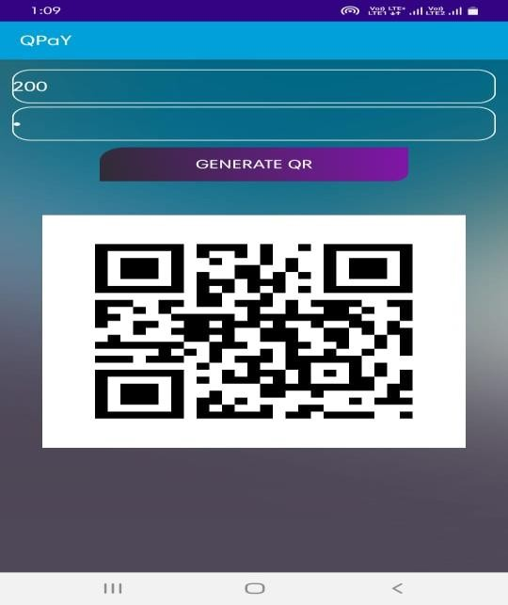Design and development of Android Application involves Android Studio which is used in to create the Application wherein the Mobile Application will have Login Page where user can Register/Login and if the user is new then the user can Register by using their Mobile number, email id and password for first time. And if the user is regular, then they can Login using their Email id and Password. Then they can enter the amount to be withdrawn. By clicking Generate QR code a QR code will be generated.

**MODULE 3: IMPLEMENTATION OF SOFTWARE-PROGRAMMING**

Programming language used are Python and Embedded C Python is for generating QR code, read the QR code from the App and to send the serial data to the microcontroller. QR code is generated using Google ZXing Package. Embedded C is used to writing and uploading programs to Arudino compatible boards. Comparing the QR code and Fingerprint is done using Verification module. If matches then motor rotates which means the 2-step authentication is completed successfully and Money will be dispensed.

# EXPERIMENTAL RESULTS

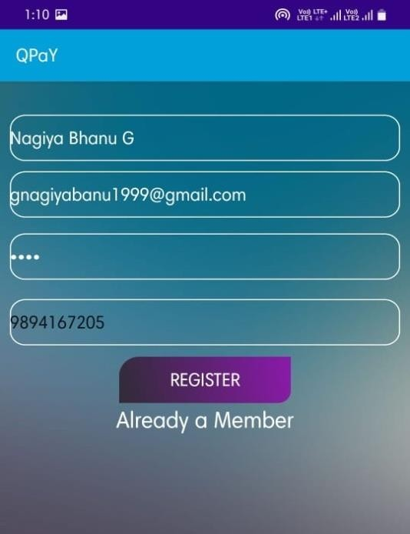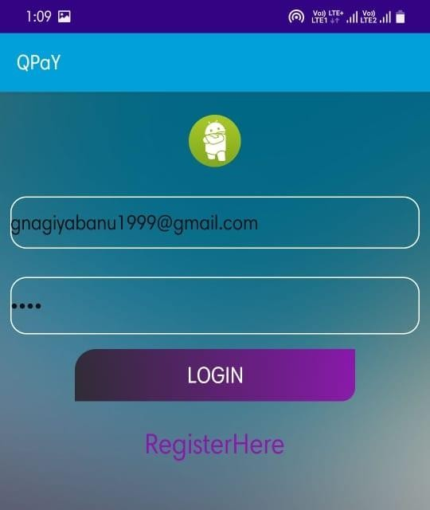

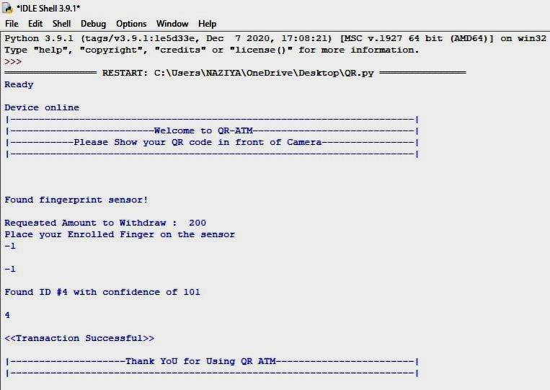

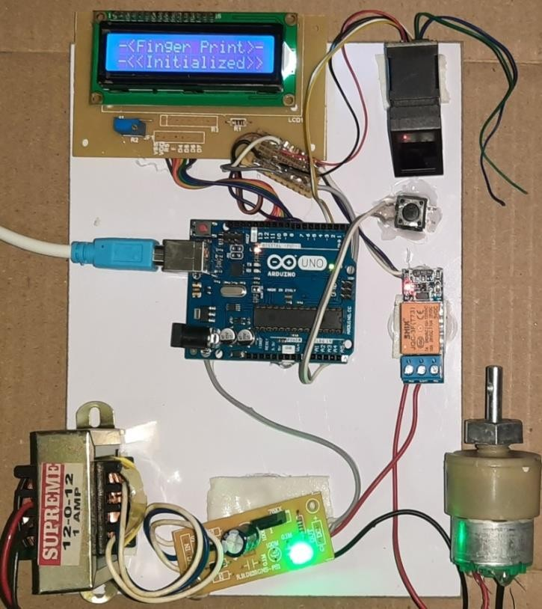

1. **CONCLUSION**

The design of this ATM system based on QR code and fingerprint recognition took advantages of the stability and reliability of fingerprint characteristics, a new biological technology. Additional, the system also Reduces Contact based use (very useful in the times like covid-19). And it is more Secured and Efficient. This project saves Human Life as we have to spend only few seconds in ATM which becomes difficult for an attacker to attack us. And Only Authorized person can use the Card as we have multilevel Authentication. This system will also be suitable for people who have very less knowledge to use ATM(s). In future even the fingerprint authentication can be done in Smart phone using sensors in it which makes it more easier. Or instead of fingerprint even face recognition can also be made.

# REFERENCES

[1]. onyesolu. m. o and ezeani. i. m, “ATM security using fingerprint biometric identifier: an investigative study”, 2012 international journal of advanced computer science and applications.

[2]. renee jebaline. g, gomathi. s, “a novel method to enhance the security of ATM using biometrics”, 2015 international conference on circuit, power and computing technologies.

[3]. sweta singh, akhilesh singh, rakesh kumar, “a constraint based biometric scheme on ATM and swiping”,2016 international conference on computational techniques in information and communication technologies (icctict).

[4]. T. R. Tuinstra, “Reading barcodes from digital imagery,” Ph.D. dissertation, Cedarville University, 2006.

[5] E. Tekin and J. M. Coughlan, “An algorithm enabling blind users to find and read barcodes,” in Applications of Computer Vision (WACV), 2009 Workshop on, 2009, pp. 1–8.

[6]. X. Q. James Juett, “Barcode localization using bottom-hat filter,” NSF Research Experience for Undergraduates, 2005.

[7]. Jun Zhou, Guangda Sua, Chun hongJiang. A face and fingerprint identity authentication system based on multi-route detection. Neurocomputing 70 (2007)922-931.

[8]. Yuliang He, Jie Tian, Xiping Luo, Tanghui Zhang. Image enhancement and minutiae matching in fingerprint verification. Pattern Recognition Letters 24 (2003)1349-1360.

[9]. Wei Wang, Jianwei Li, Feifei Huang, Hailiang Feng. Design and implementation of Log-Gabor filter in fingerprint image enhancement. Pattern Recognition Letters 29 (2008) 301-308.

[10]. Arju Aman,Aryan Singh,Ayush Raj and Sandeep Raj.An Efficient Bar/QR code recognition system for consumer service applications. Pattern recognition letters 2020.